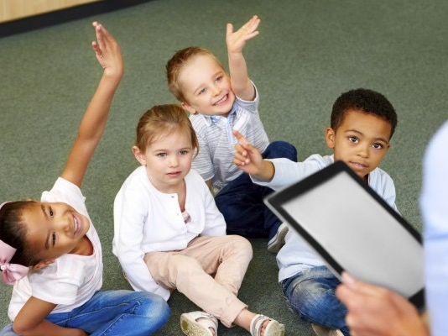
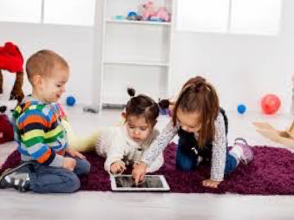
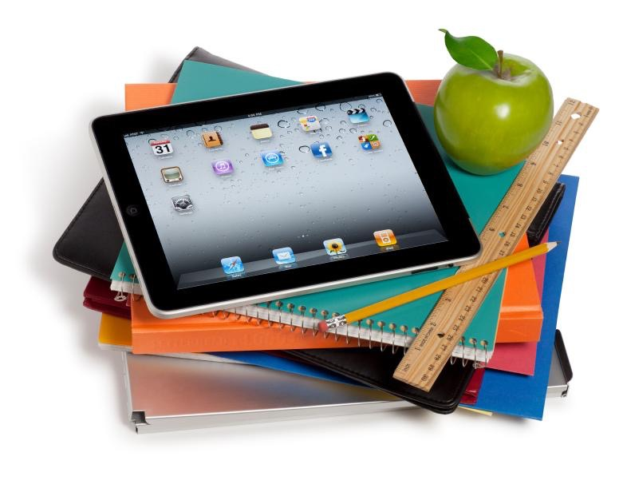
Technology Resources for Your Learner!

Carson Fuchs & Emily Fox

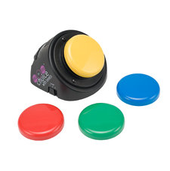
Technologies

Switch Play
With Switch Play, children that are non-verbal or have low motor coordination are able to communicate, make choices, and direct their play and learning. By recording messages, the child is able to communicate with parents/teachers as well as allows parents and teachers to communicate Switch Play has multiple capabilities including multi-step options to record more than one message.
Target population: Toddler +
Skills covered: Communication
Usefulness - Augmentative: The switch play is hands on, encourages communication, gives non-verbal students independence and confidence to communicate their needs.
Availability: Ablenetinc.com Early Intervention & Special Ed Programs
Price: $60.00-$400.00
Resource for classroom & in home use
Research:
http://www.childtrends.org/?programs=switch-play

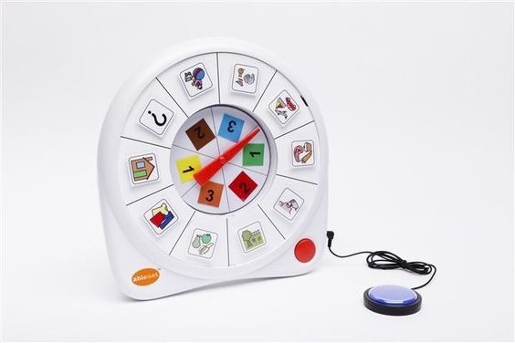

AllTurnIt Spinner
This is a tool for decision making in the home or classroom. The student selects from interchangeable slots of activities or tasks by pressing a button. The decision is random, but the student is still getting into the habit of making effort towards a decision.
Targeted population: Pre-K
Skills Covered: decision making, taking direction, participation
Availability: Online, ablenetinc.com/all-turn-it-spinner
Modification: Make your own: Tutorial - http://adaptingcreatively.blogspot.com/2011/07/diy-switch-adapted-spinner.html
Usefulness- Augmentative: Students are able to practice decision making in a fun and pressure-free way.
Price: $119.00
Resource for classroom & in home use
Research: http://www.childtrends.org/?programs=switch-play
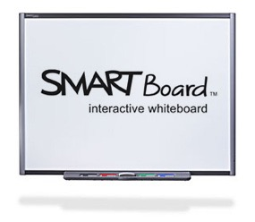
Interactive Whiteboard
Many schools have Interactive Whiteboards in their classrooms. These allow teachers and students to perform traditional whiteboard tasks such as writing as well as have the ability access the Internet and other software/activities.
Target population: Pre-K +
Skills covered: Math, Writing, Reading, Social Studies, Science, etc.
Availability: Retail, Online
Usefulness - Instructional: Smartboards offer a hands on an unique way for students to participate in class as well as for teachers to implement interactive activities into their curriculum such as the Internet and other softwares.
Price: $2000-$7000
Resource for classroom use
Research: https://www.naeyc.org/files/yc/file/200809/OnOurMinds.pdf

SKYPE
Skype is a live video messaging software that allows students, teachers, and parents to communicate in real time throughout the world.
Target population: Toddler +
Skills covered: Communication, Social Studies, Social Emotional
Usefulness - Instructional or Augmentative: This software allows participants to communicate across the globe in real time. Skype is available on phone, tablet, or computer. Students can communicate with loved ones, therapists, family members, or other students.
Availability: www.skype.com software download, iPad, iPhone, computer
Price: $2.95 per month (Additional cost for group options)
Resource for classroom & in home use
Research: http://www.naeyc.org/files/naeyc/file/positions/PS_technology_WEB2.pdf
Electronic Timers
http://www.online-stopwatch.com/classroom-timers/
Timers are an effective way to help students with pacing and transitioning from class to class. Online Stopwatch has classroom timers with fun themes to help students move from task to task.
Target population: Pre-K+
Skills covered: Pacing, Transitioning
Usefulness - Instructional/Augmentative: Timers are fun and exciting and help students transition. It creates something for kids to look forward to as opposed to teachers queuing them.
Availability: Online
Price: Free
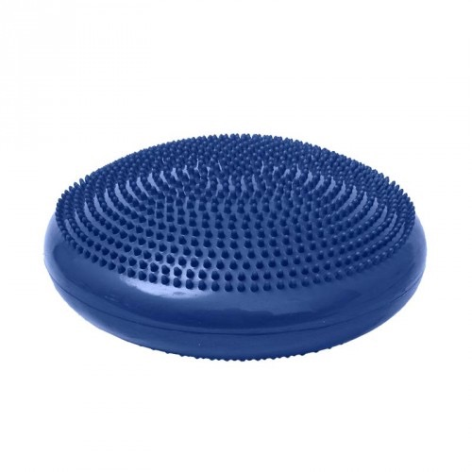
Research: http://www.cu-portland.edu/coe/thesis/documents/timfox.pdf
Spiky Tactile Cushion
This is an assistive technology that provides sensory stimulation to learners. Students are able to sit on the cushion throughout the school day and it gives them sensory stimulation
Target population: All ages
Skills covered: Focus and Attention, Posture, Self Regulation
Usefulness - Augmentative: Great for students that have a hard time staying in their seats. Students are able to keep working while still receiving stimulation to keep them calm.
Availability: Retail, Online
https://funandfunction.com/spiky-tactile-cushion.html?gclid=CjwKEAjw55K4BRC53L6x9pyDzl4SJAD_21V1pU9D8ovJaVXo16PzNKG109uYAclBj8jejYyRRqEZ2hoCk9Xw_wcB
Price: $29.99
Resource for classroom use
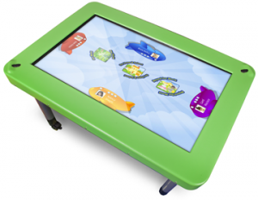
Research: http://soundideas.pugetsound.edu/cgi/viewcontent.cgi?article=1079&context=ms_occ_therapy

WePlaySmart by Hatch Interactive Learning Center
This software helps children develop social emotional skills through making choices, cooperation with peers, and exploring of multiple roles. It offers 6 game types: Uncover, Sort, Find, Vote, Turns, and Connect on a multitouch learning table
Target population: Pre-K
Usefulness - Instructional: Fun and new way for children to do hands on social emotional learning.
Availability: www.hatchearlylearning.com/store
Price: Call for pricing : 800-624-7968
Resource for classroom use
Research: https://educators.brainpop.com/printable/study-effectiveness-brainpop-executive-summary/

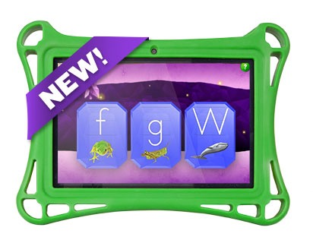
iStartSmart Mobile tablet
Research-based early learning software that monitors child’s progress while allowing them to engage in core skill area games.
Target population: Pre-K
Skills covered: Early learning core skills, Kindergarten readiness
Usefulness - Instructional: Tablet monitors child’s progress with data. Identifies child’s abilities individually. Research based and core skill oriented.
Availability: www.hatchearlylearning.com/store
Price: Call for pricing 800-624-7968
Resource for classroom & in home use
Research: http://www.hatchearlylearning.com/technology/istartsmart-mobile/improved-outcomes/

Audio Books
Students can have books read to them aloud individually with headphones. This helps students learn to follow along, as well as work at their own pace. Many different types are available.
Target population: All ages
Skills covered: Reading
Usefulness - Instructional/Augmentative: Great for students that struggle with reading, as well as those that require auditory learning.
Availability: Amazon, Individual websites, iTunes, iPad, Computer, iPhone
Price: Varies by product/package
Resource for classroom & in home use
Research: http://www.techandyoungchildren.com/tech-on-deck/

BlueBee Pals
Plush talking educational tool that sings, reads, and answers phone calls. They enable students with communication delays to communicate through a soft and plushy toy. The BlueBee pal’s mouth even moves as it speaks. It connects to a bluetooth on your Smart phone, Tablet, or Laptop.
Target population: Toddler+
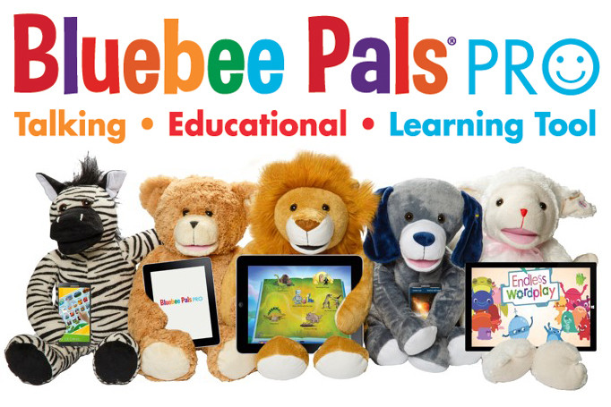
Skills covered: Communication
Usefulness - Augmentative: Children are able to communicate through a toy. Soft and fun. Realistic to the child’s imagination.
Availability: www.bluebeepals.com for Smart Phone, Tablet, Laptop
Price: $64.99
Resource for classroom & in home use
Research: http://bluebeepals.com/pages/press

Interactive Websites

BrainBop Jr.
BrainBop Jr is an interactive website for students to practice a variety of subjects in a Standards Based fun game setting.
Target population: K-3
Skills covered: Science, Health, Reading, Writing, Social Studies, Math, Arts & Technology
Usefulness - Instructional: Fun and Interactive, Standards based, Measures progress
Availability: http://jr.brainbop.com
Price: Classroom Subscription - $160 per year
Family Subscription - $99
ESL also available
Resource for classroom & in home use
Research: https://educators.brainpop.com/printable/study-effectiveness-brainpop-executive-summary/
GoNoodle
www.gonoodle.com
GoNoodle is an interactive website full of brief “Brain Breaks” for your child. These include movement activities, song & dance, kinesthetic learning, coordination, and calming exercises.
Targeted population: Toddler+
Skills Covered: Gross motor, Self Regulation, Kinesthetic learning
Usefulness - Augmentative: This website is easy to navigate and full of a variety of activities for students. It can be accessed in the classroom or at home. Activities are short and sweet!
Availability: Online
Price: Free membership, GoNoodle Plus available for $10 a month ($99 for a year subscription)
Resource for classroom & home use.
Research: http://blog.gonoodle.com/2014/12/neuroscience-for-teachers-applying-the-research/
ABCYa
www.abcya.com
This is an interactive website with a variety of fun and interactive activities for students in a game format.
Targeted population: Pre-K through Primary
Skill covered: Reading, Writing, Mathematics, Problem Solving
Usefulness- Instructional: Students are able to practice educational curriculum in a fun and interactive way. This website offers a class and family option for in home or classroom use. Activities are available by grade level and align with Common Core Standards
Availability: online, www.abcya.com, tablet, mobile phone
Price: Free
Resource for in class & at home use
Research: www.abcya.com/FAQ

Apps

Handwriting without Tears: Wet, Dry, Try Capital Letters and Numbers
This application for iPad follows the Handwriting without Tears curriculum used in many classrooms to teach children to write their letters from the top down. Students are able to practice writing over and over without mess by tracing letters on the iPad with their finger or a stylus for increased fine motor practice.
Targeted population: Pre-K
Skills covered: writing, fine motor control
Usefulness - Instructional: Students are able to practice classroom activities while incorporating the novelty of the iPad. Students are still able to play as they learn.
Availability: iPad 2 and newer, AppStore
Price: $6.99
Resource for at home use.
Research: https://www.hwtears.com/hwt/why-it-works/research

White Noise by TMSOFT
This application creates a low frequency of plain static-like noise that can calm children and aid them in cognitive functions.
Target population: APD students, inattentive students, Pre-K +
Skills covered: Self regulation, Attention
Usefulness - Augmentative: This app is easy to open. Volume of sound is adjustable. Creates clear white noise.
Availability: App Store, iPad, iPhone
Price: $1.99
Resource for in class & at home use
Research: https://www.sciencedaily.com/releases/2010/09/100928193445.htm

ArtikPix by Expressive Solutions LLC
ArtikPix is an articulation app to help students with speech and sound delays. It has 24 decks of flash cards for matching activities that range from Easy to Hard. Activities use recorded audio, voice recordings, and scoring (data collection)
Target population: SLP students, Pre-K+
Skills covered: Articulation, sound pronunciation, Phonics
Usefulness - Instructional/Augmentative: This app helps students practice their sounds while allowing them to hear their own sounds recorded, listen orally, and advance from level to level. Data is collected for parents/teachers to measure progress. The graphics are fun and it offers a game like activity for kids.
Availability: App Store, iPad, iPhone
Price: Free with In App Purchases (Sound decks) $2.99 each
Resource for in class & at home use
Research: http://ilc.com.au/wp-content/uploads/2014/06/using-ipads-in-speech-pathology.pdf

Smart Oral Motor by Smarty Ears
This app is designed to help students complete oral motor exercise routines in an interactive fun way as a modification of a traditional test administered by Speech Therapist instruction.
Target population: Ages 5-10 Students with apraxia, articulation disorders, and autism.
Skills covered: Basic motor functions for eating and speaking
Usefulness - Augmentative: This app helps students practice facial expressions such as puckering lips, making an o with their lips, sending a kiss, and puffing their cheeks in a fun and interactive way. It’s easily accessible by iPad or iPhone.
Availability: App Store, iPad, iPhone
Price: $5.99
Resource for in class & at home use
Research: https://www.scribd.com/doc/50919979/Articulation-Apps-for-Speech-Therapists-by-GeekSLP

Pictello - Talking visual story creator
Many students benefit from visual representations to help them transition through their day. This app brings social stories and visual schedules to life. Users have the option of creating their own stories using the iPad or iPhone with photos, video, and audio recordings.
Targeted population: Pre-K +
Skills covered: Transitions
Usefulness - Augmentative/Instructional: This app allows students to practice procedures and routines by referencing real life photos and videos created specifically for them.
Availability: App store, iPad, iPhone
Price: $19.99
Resource for classroom & in home use
Research: http://www.naeyc.org/files/tyc/file/TYC_V4N1_BriodyMcGarry.pdf

ChatterPix Kids
ChatterPix lets students create illustrations and record their descriptions, bringing them to life! This is a great app for students that have trouble articulating their thoughts in writing as well as encourages creativity.
Target population: Ages 6-12
Skills targeted: Art, Creative writing, Describing
Usefulness - Augmentative: Gives students opportunity to expand on their illustrations even if they do not have the capability to write.
Availability: App Store, iPhone, iPad
Price: Free
Resource for classroom & in home use
Research: http://www.duckduckmoose.com/testimonials/

MyVoice
This app is designed to help non-verbal, low cognitive people communicate needs by recording simple messages the child may select to communicate.
Target population: Non-verbal, cognitive delayed
Skills targeted: Communication
Usefulness - Augmentative: MyVoice is easy to operate and gives a voice to the non-verbal
Availability: Apple iOS devices & Android
Price: $49.99
Resource for classroom & in home use
Research: https://www.autismspeaks.org/family-services/resource-library/assistive-technology

