Carson Fuchs
Practicum Rd. 1
Mrs. Becky Echelbarger

SOLAR

Age Level: Pre-K
Subject(s) Area: Math Review/Writing

Materials Needed:
Number Popsicle Sticks
Paper Clips
Dry Erase Board & Marker
Play Dough
Mini Chalk Boards
Chalk
Sponges
Water
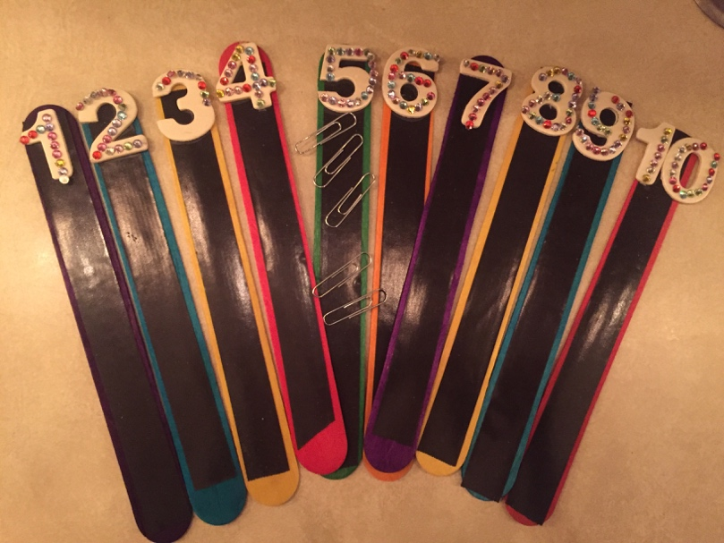

Standards: (Pre-K or Kindergarten Standards or Early Learning Guidelines)

MTH.1.4 Demonstrate understanding of one-to-one correspondence between objects and numbers
MTH.1.2. Use number names with written numerals
L.L.3.3. Use Writing tools and materials

Objectives:

Students will review One-to-One Correspondence numbers 1-10
Students will manipulate materials to write the number 6
Students will write the number 6

Learning Activities:
I will present a One to One Correspondence activity to students.
I will give students numbered sticks 1-10 with magnetic strips on each.
Students will count the corresponding number of paper clips to their stick and attach the clips.
The students will count aloud as a group.
I will collect the sticks and turn students’ attention to the board.
Using Hand Writing Without Tears terminology, I will demonstrate how to write the number 6.
Students will be dismissed to their tables to practice forming the number 6 with play dough.
After a short time, I will collect the play dough and distribute chalk boards, chalk, and wet sponges.
Students will practice writing the number 6 on their chalk boards.

Reflective Questions:
Where do we see the number 6? What happens when we put two numbers side by side? Why do you think the paper clips stick to the number sticks? How do we know?

Vocabulary: 1-10, magnetic, magnet, paper clip, bear cub

Assessment:
Informal:
I will observe students’ participation in activities.
I will observe students as they complete writing their 6’s.
Formal:
Students will be tested at the end of the year.

Reflection:
This activity went extremely well. Students did a great job with the one-to-one correspondence activity. I had an awareness of students that were struggling with number identification, and in this instance, it worked out that those students were able to select numbers within their abilities. I also had students count as a whole group in order to avoid any obvious struggling by any particular student. The students were very sharp about the magnets, and although I’d planned to ask them about the magnets, they knew quite a bit. However, I think it was fun for them to play with the clips and magnets. In the future, however, I would try to work out a way to take the number stick back once they had finished with them, as opposed to leaving them in front of the students. I think it’s important to leave the numbers out for potential extension, such as naming large numbers or ordering them, but still having students be able to focus on counting their classmates as well. Some students became fixated on lining up their paper clips perfectly, etc.

This was my second number writing lesson with the students, so they were familiar with how it was going to go. It was in my observation that they learn their numbers and letters of the week in a pretty routine way. Students held their attention to learn how to write the number 6, and eagerly went to their tables to practice with play dough. Some students still needed review on how to make the “snake” to form the number, but all of them were able to complete them. They also did a great job with the chalk boards. I was concerned with the length of the lesson, but because we switched up the activity 3 times, it went well. If I were to do the same lesson in the future, I would consider adding more intentional transitions in between, or even a brain break.

