Parental Involvement Toolkit
Carson Fuchs
EDU 413
April 29, 2016

Introduction

The following document contains strategies, activities, and plans in order to increase parental involvement in the Elementary classroom setting. It highlights six major categories that are necessary for the parent/teacher/community relationship: Parenting, Communicating, Volunteering, Learning at Home, Decision Making, and Collaborating with Community.

Parenting
The parent plays a significant role in the type of student that appears in the classroom. The student’s behavior begins at home, with the parent. Many factors contribute to good parenting, and it is important to equip parents with the tools and resources to learn about and provide what their children need.
I have put together a plan for a Parent Resource Room. Olsen and Fuller (2012), suggests resource rooms as a “family-friendly center where parents can come together and discuss parenting issues and check out resources and materials.”
Ideally, the Parent Resource Room would exist individually in its own physical space. But in its beginnings, I intend to open a portion of my classroom every other Friday before and after school for parents to come in, visit with each other, visit with me, and check out or look through materials. I will provide a bulletin board for parents which will operate as a hub for community and school goings on that they can attend with their spouse, their children, or on their own. It will include workshop opportunities and information regarding Parenting classes, as well as a brochure of statewide agencies. It will also include suggestions of FUN things parents can do with their kids. Finally, the Resource Room will have its own mini library of literature and other resources that parents will be able to check out and take home.

Statewide Agency Brochure

Family Voices. 312 2nd Avenue W. Edgely, ND

Family Voices is an organization that provides assistance to families with special needs. They offer information to families through workshops, information publications, and 1:1 assistance via phone or email. Their mission is to educate families in positive ways to advocate for their children’s needs, offering medical guidance, resource library, resource suggestions, and putting on events and workshops.

Catholic Charities. 216 S Broadway. Minot, ND

Catholic Charities offers support to families in multiple walks of life. Some of the programs include Pregnancy, Parenting, and Adoption services, Adults Adopting Special Kids (AASK), Guardianship Services, Counseling Services, and Disaster Response. Catholic Charities describes their mission to be partnership with the belief in the Catholic church and the sacredness of personhood, advocating for the common good of all people.

North Dakota Center for Persons with Disabilities. 500 University Avenue West. Minot, ND

In affiliation with Minot State University, North Dakota Center for Persons with Disabilities provides information, research, and education to the community about people with disabilities. This organization operates under four main goals: creating inclusive communities, developing workforce for people with disabilities, self-determination, and improving healthcare systems to foster healthy citizens of the community.

Community Options, Inc. 300 3rd Avenue SW, Suite D. Minot, ND

Community Options offers residential opportunities for people with disabilities. They offer personalized services that encourage individuals to live independently while meeting their needs. Community Options has programs that include day, residential, in-home, and family support assistance.

Easter Seals Good Will of North Dakota. 800 12th Avenue SW. Minot, ND

Easter Seals Good Will offers a variety of services to the community including family care, individualized support living, family support, home and community based services. They also provide equipment loans to individuals with disabilities such as wheelchair rental. The organization offers referrals to individuals for a variety of therapies.

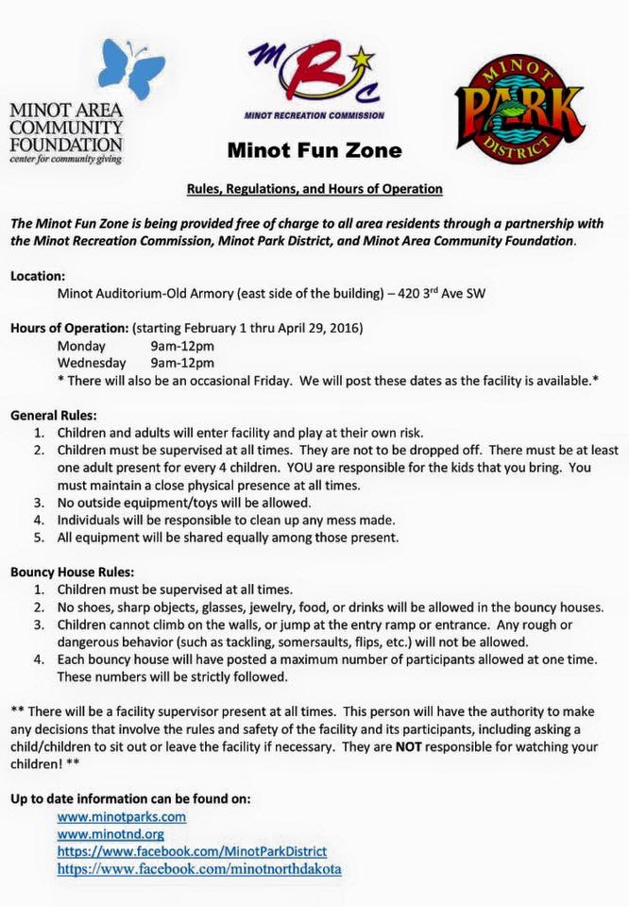
Sample Community Events Handouts

Communicating

Communication refers to the two-way interaction between home and school. Without effective communication between home and school, other aspects of parental involvement becomes increasingly difficult. (Olsen & Fuller, 2012, p. 136) Communication is foundational aspect of Parental involvement.
One strategy I plan to implement in my classroom to encourage communication with parents is a classroom webpage. However, I would like to use Facebook as the platform. According to Baskwell (2012) , “ Teachers are encouraged to go where the parents are; more parents are apt to be on Facebook or Twitter every day, whereas they might check the class webpage only once in a while or when reminded.” Under the notion that majority of parents have Facebook on their computer and even their phone, I will create a Private Group for my classroom.
The group will be by Invite Only, where parents will be able to receive notifications of status updates, photos, and videos of classroom goings-on. Facebook also has the capability of creating “Events” that parents can accept or decline. This tool could be used for class meetings, performances and music programs, and even Parent-Teacher conferences. The parents will be able to “like” and “comment” on classroom updates as well as post on the classroom “Wall”, but all comments and posts will be “pending” until approved by me, their classroom teacher. The Facebook page will serve as positive and contemporary way for parents to keep up with their kiddos, as well as communicate with the teacher.
Operating under the Group as opposed to a personal account also provides a professionalism between the teacher and parent. Parents will not be able to communicate with the teacher through the Facebook messenger App, as the group will not be affiliated with a specific individual account.

Volunteering

Finding volunteers is a struggle that many schools experience. Making volunteer opportunities a requirement defeats the purpose of volunteering, but that does not take away from the importance of emphasizing volunteerism to parents and students in the school setting. According to Epstein (2007), as cited by Olsen and Fuller (2012), “approximately 70% of parents have never helped the teacher in the classroom, and only 4% of the parents (about one or two parents per classroom) were highly active at school. By giving parents volunteer opportunities that help the school both in and outside of the classroom, parents are given more choices that are convenient and are able to work it into their schedules.

In Class Volunteering:

Classroom Helpers, or “Room Moms” are still a very common aspect of the Elementary classroom. I would provide an online sign up schedule to parents encouraging them to take time to come into the classroom. I believe an important aspect of having parent volunteers is to give them a choice in when to come in during the school day and what they will do with the children.

A tentative Daily Schedule will be posted on the classrooms Facebook page ( as well as updates if the class is on a different schedule for the day) that parents will be able to reference in signing up to come in to the classroom.
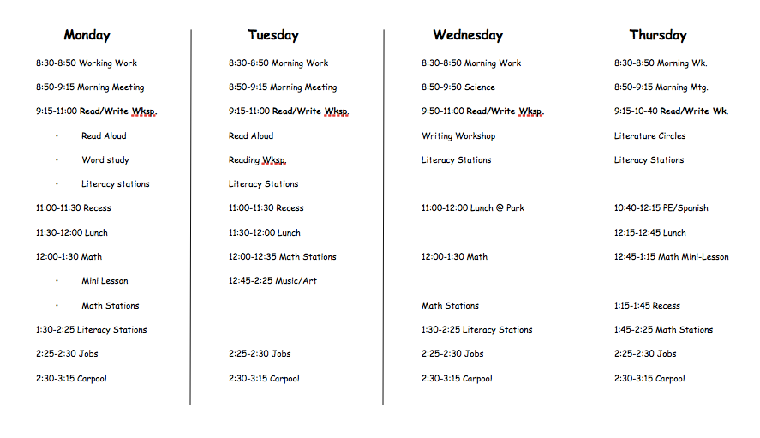

Volunteer Spot Website: www.volunteerspot.com

Out of Classroom Volunteering:

Olsen & Fuller (2012) note that simply putting adult presence in school activities is an example of “Volunteers as Audience”. This concept asks parents to attend school or class events, sporting events, open houses, fun nights, and recognition and award ceremonies.

In order to increase parent and student interest, I will send out formal “Invitations” to school events. This transforms the school event into an occasion for both student and parent.

Learning At Home

Another way to get parents involved in their child’s education is by continuing learning in the home. As the classroom teacher, I can help facilitate those learning experiences by sending home “mobile learning centers” with students. According to Olsen & Fuller (2012), mobile learning centers consist of a bag with two or three hands on activities to either promote several different developmental areas or a specific skill. Each bag has a parent letter, directions for the activity, parents’ feedback journal, and materials needed for the activities.

The Mobile Learning Center bag will circulate to a child once a week, and I will change out activities as the bag circulates. This will provide students with extra opportunity to work on a specific skill, as well as work together with their parent.

Hello Parents!

Welcome to your Mobile Learning Center. It is your child’s turn to have an opportunity to show you hands-on activities that we are working on in class!

This week, we are working on fine motor skills like cutting, holding our pencils and crayons, and squeezing tools like hole punchers. Inside the Mobile Learning Center, you’ll find everything you need to complete these activities with your child. Don’t worry about replacing any of the materials — just have fun with your kiddos, fill out the parent feedback journal upon completion, and send the bag back with your student on Monday!

Thank you,
Miss Fuchs

Center Contents

The Very Hungry Caterpillar by Eric Carle

Leaf Cutout

Hole Puncher

Caterpillar Coloring Sheet

Crayons

Parent Feedback Journal

Activity Instructions:

#1. Read “The Very Hungry Caterpillar” by Eric Carle with your learner. We have read this book in class, so encourage them to tell you about it as you’re reading.
#2. Have students practice using the hole-punch into the leaf, like the hungry caterpillar. As an extension, you can have them count out loud for you as they punch.
#3. Invite your learner to color their Hungry Caterpillar coloring sheet. Watch for how they are holding their crayons or markers, and encourage them to hold them correctly.

Once you’ve completed your activities, please write in the Parent Feedback Journal. Thoughts to include may be:
How did the activity go with my child?
What did my child like about the activity?
Any additional comments or suggestions for the teacher

Decision Making

Decision making in the school setting can take on many forms. Decision making is required in the larger scale in the form school wide decisions, budgets, etc. On the smaller scale, parents may also want involvement in what is happening in the classroom. At the finest level, parents desire the opportunity to advocate for their child as an individual.

Many of the previously discussed strategies involve parents on the small classroom scale such as feedback capabilities on the Facebook page and Parent Feedback Journals.

At the individual level, one Decision Making strategy I will implement is regular correspondence with parents regarding their child’s progress. I intend to have an open door policy and offer regular correspondence with parents’ as well as opportunity to set up meetings aside from school determined Parent-Teacher conferences. During my classroom’s open house, I will send a two part card home with parents. On the first side of the card, they will find my contact information, office hours, etc, for them to keep as a reference. On the second part of the card, parents will have the option of selecting a box for updates of their child’s progress throughout the school year, which they have the option of returning to me.

At the larger scale, I want to encourage parents to become involved in school wide decision making through programs such as the PTO. The best way for me to get parents involved in school organizations is by providing information to them about that organization so that they are able to decide whether or not they are interested in the decision-making processes that take place. PTO is very similar to volunteering in that it is completely up to the parents, so I as the classroom teacher must represent it as a positive choice for the parents for their children. I would send a Parent Letter home regarding options to get involved with the PTO to get information to parents as well as provide resources such as sample handouts and website information.
Send me daily emails
Call me at the end of each week
Parent Name:
Please Choose Your Preferred Option

Send me an email at end of the week
See you at conferences!
My Information

Miss Carson Fuchs

Email: cmfuchs1@umary.edu

School phone: 701-555-5555

Office hours: Monday-Friday 7:00-8:00am
&
Monday-Friday 3:00-4:00pm

PTO Sample Parent Letter

Dear Parents,
I would like to officially invite you to participate in our school’s formal committee for decision-making such as curriculum decisions, budgeting, materials, and volunteerism opportunities. Our school participates in the Parent Teacher Organization (PTO) program. The mission of the National Parent Teacher Organization is to to serve as an advocate for you as a parent group for your school. The PTO provides information, volunteer opportunities, as well as opportunities for you to actively participate in school functions and activities. The PTO is responsible for fun nights, school dances, and awards ceremonies. This organization has received a number of awards for such as Blue Ribbon Schools, Green Ribbon Schools, and President’s Awards. Our PTO meets every other week in our school gym from 6:00PM to 7:30PM, with our first meeting on Tuesday, September 13th. All are welcome to attend!
You can find more information on the National Parent Teacher Organization at www.pto.org

Thank you!
Miss Fuchs

Collaborating with Community

Many communities offer opportunities for parents, schools, and students to become involved with their community, as well as attend community events that can benefit them in the areas of education, extracurricular, workshops, and resources.
I believe the best way to provide awareness of this availability for parents is with a combination the aforementioned resources.
For example:
The Parent Resource Room bulletin board will contain a variety of information resources such as community events, statewide agencies, and workshop/volunteerism opportunities.
To create more accessibility, I will place a filing folder beneath the bulletin board with extra copies of information for parents to take home with them. The binder will be labeled by concept as well as date so that it is easy for parents to find information.
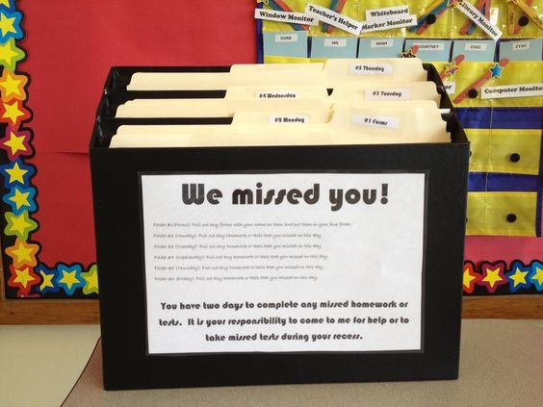
Sample: Many teachers have files for absent students to find work they have missed. The folder beneath the bulletin board would look similar to this but be labeled by concept with sub labels for specific dates.

A second example of utilizing previous strategies is to create community awareness by sharing Community Events to the Classroom Facebook Page.

References

Olsen, Glenn. Fuller, Mary Lou. (2012). Home and School Relations: Teachers and Parents Working Together. Upper Saddle River, New Jersey: Pearson Education.
Baskwill, Jane. (2012). Attention Grabbing Tools: For Involving Parents in Their Children’s Learning.Pembroke Publishers Limited.
Facebook Settings. (n.d.) Retrieved April 26, 2016, from http://www.facebook.com/Settings
Minot Fun Zone [Photo file]. Retrieved from http://www.facebook.com/MinotParkDistrict/photos
Daily Schedule Template. (2015). [Word Document File] Retrieved from https://www.teacherspayteachers.com/Product/Daily-Schedule-Template-291004

PTO . (n.d.). Retrieved April 28, 2016, from http://www.pto.org/about.html

